FAQ  -What does my skater need for this camp?  Your skater needs proper skating attire for on-ice sessions, runners, yoga mat, water bottle for off-ice, healthy snacks and lunch, and a positive attitude!  - Are skills and dance optional?  Skills and dance are included in both packages, however skaters who have finished their skills and dance tests may opt out.  - Is freeskate part of the package?  Yes, each Package includes a Freeskate session. There is an extra session at the end of the day that anyone can add on to their package price.  -What is the Seminar Session?  This session will be run as a group class by one of the coaches and focus on one aspect of skating each day, for example, jump technique, ice dance, edges, etc.  -What is included in the price?  EVERYTHING! All of your skaters sessions and lessons are included in the registration price. The extra cost is if your skater decides to participate in activities at the end of the day. |  |  | Taber Skating  Corn Camp  - August 13th-17th 2018  - 9:00 am- 3:00 pm  - 4712 50 St, Taber, AB T1G 2B6  - All Skaters Stage 4 CanSkate and Up  - Outside clubs and coaches welcome!  - ** Registration Deadline: July 31st ** Register online at: taberfigureskatingclub.com  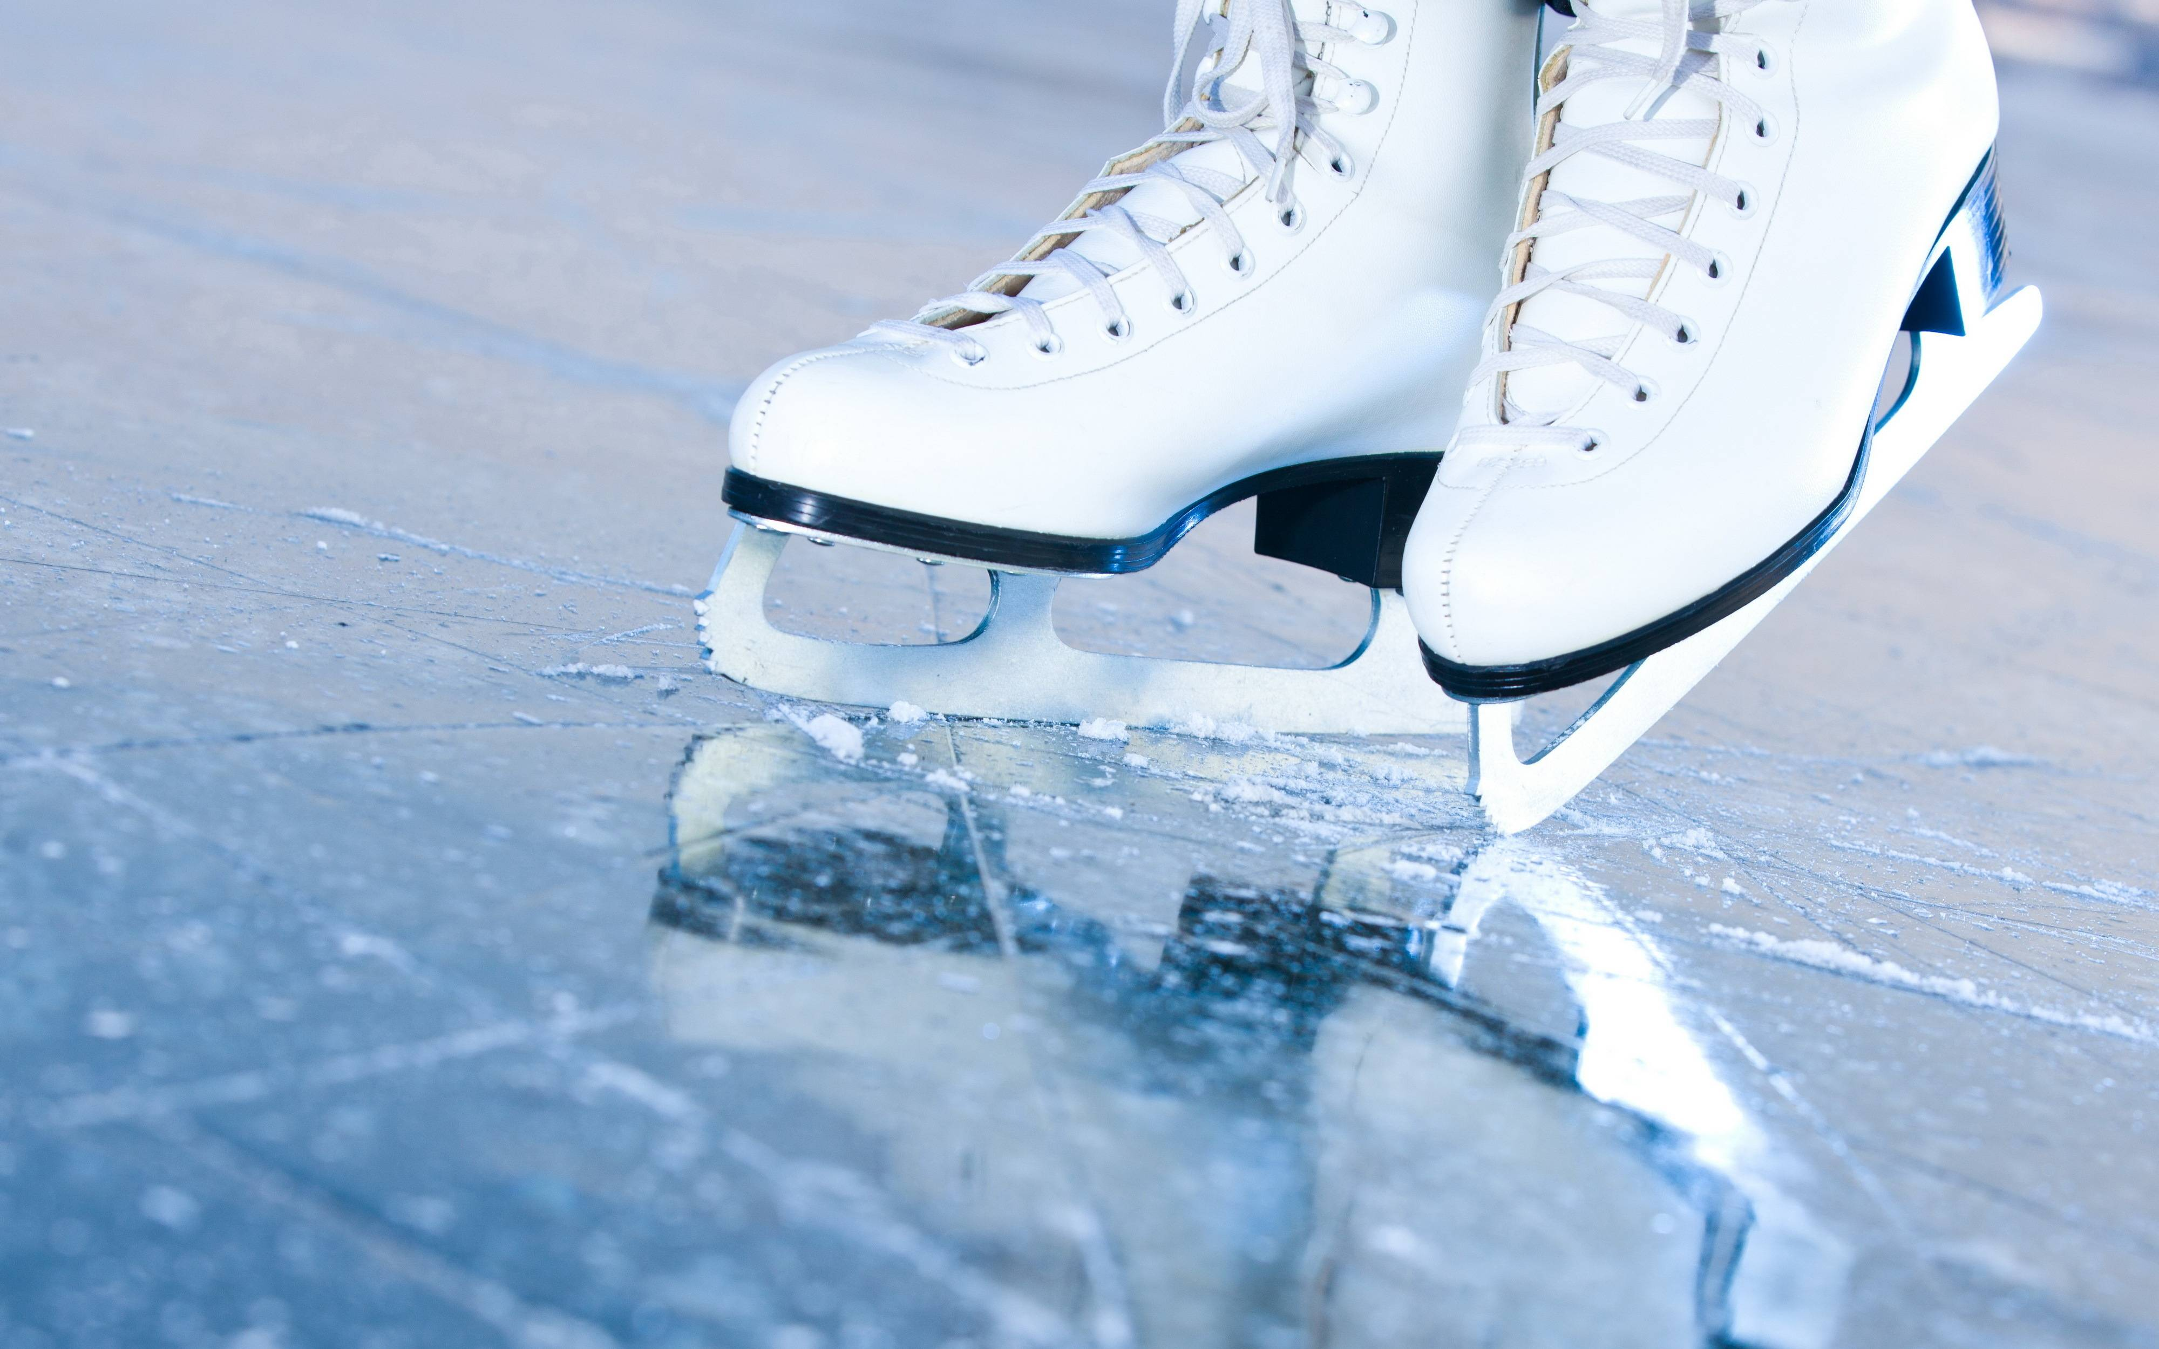

Package A  $215 per skater  Recommended for Canskate Stage 4- Star 4 (not landing axel)  Includes: Circuits, Dance and Skills, Spins, Off-Ice, Freeskate, and Creative  Package B  $265 per skater  Recommended for Star 5+ (skaters landing axels)  Includes: Off-Ice, Spins, 2 Freeskates, Stroking, Sports Psych, Seminar, Skills and Dance  Coaching Included With:  All sessions have coaching included in the registration price. Students will be grouped according to level and every effort will be made to keep students with their regular coaches.  Extra Activities (After ‘Package A’ Creative session)  $35 for 5 days (Mon- Thurs)  Test Day Friday!  There will be a test day starting 1PM on Friday, August 17th. Wayne Lumley will be attending as dance partner. Ask your coach if you are ready to test! | Package A  9:00- 9:15 Circuits (on-ice  9:15- 9:45 Dance/Skills  9:45- 10:00 Spins  10:00- 10:15 Flood/ Break  10:15- 11:15 Off-Ice  11:15- 12:00 Lunch  12:00-12:45 Freeskate  12:45-1:00 Creative  1:30- 2:30 Optional Activity  Package B  9:00- 10:00 Off-ice  10:15- 10:30 Spins  10:30- 11:15 Freeskate  11:15- 11:45 Stroking  11:45- 12:00 Flood/ Lunch  12:00- 12:15 Lunch  12:15-12:45 Sports Psych  1:00- 2:00 Freeskate  2:00-2:30 Seminar  2:30-3:00 Dance  Drop-In: $45/day Package A  $55/day Package B | Contracted Coaches  Kathleen Ward  Olea Taboulchanas  Amanda Hillier  Shaelin Westerson  Jessica Watson  Taylor Straga  Sports Psychology Topics  Dealing with Distractions, Goal Setting, Nutrition, Visualization, Self-talk  Off-Ice Activities  Dance, Off-Ice Jumps, Flexibility, Strength, Technique Analysis  Contact Us taberfigureskatingclub@outlook.com  kathleen.ward2@uleth.ca  Website  taberfigureskatingclub.com  Registration Deadline: July 31, 2018  Late registrations are subject to a $20 late fee.  Lessons with non-contracted coaches are not included in the package prices.

